1. **Create two separate branches from master**

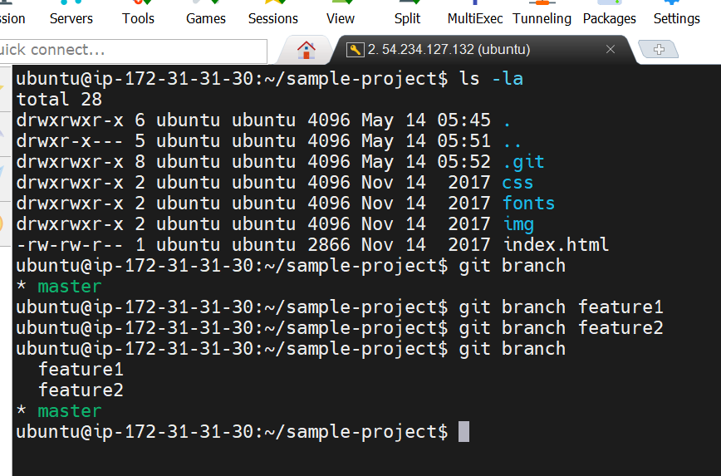

1. **Make changes in the same function of the source code in both the branches**

**--On branch feature1**

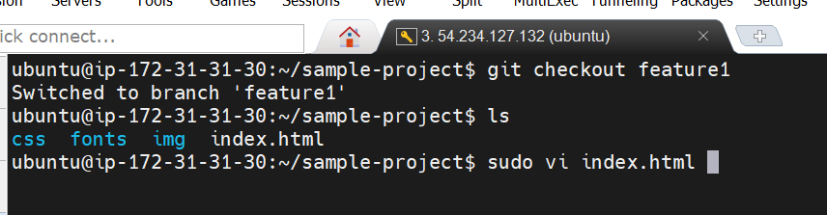

**Change title “HTML Application to “Welcome to the HTML Application”**

**And save it using**

**Press ---esc and :wq!**

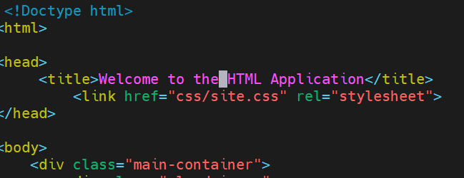

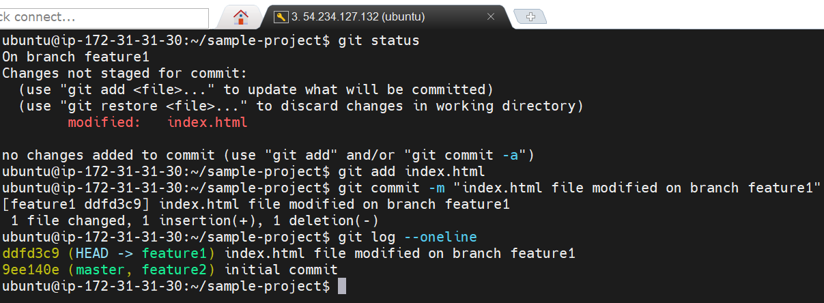

**---On branch feature2**

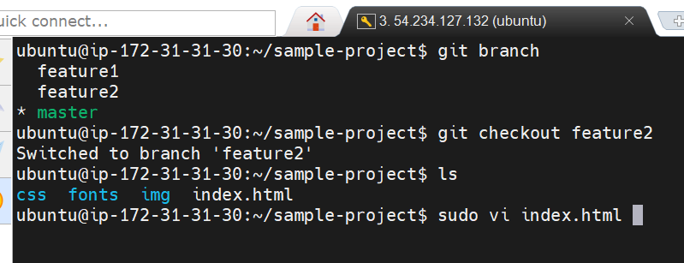

**Change title “HTML Application to “Welcome”**

**And save it using**

**Press ---esc and :wq!**

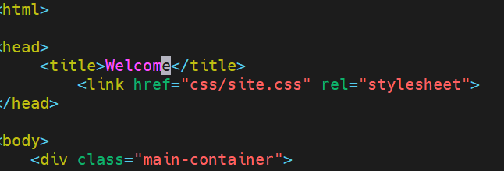

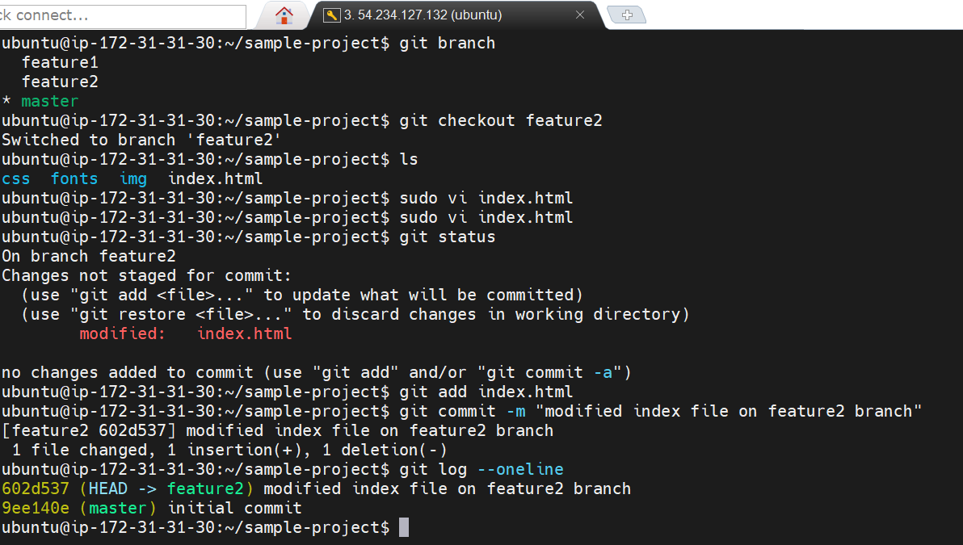

1. **Merge branch1(feature1) into the master**

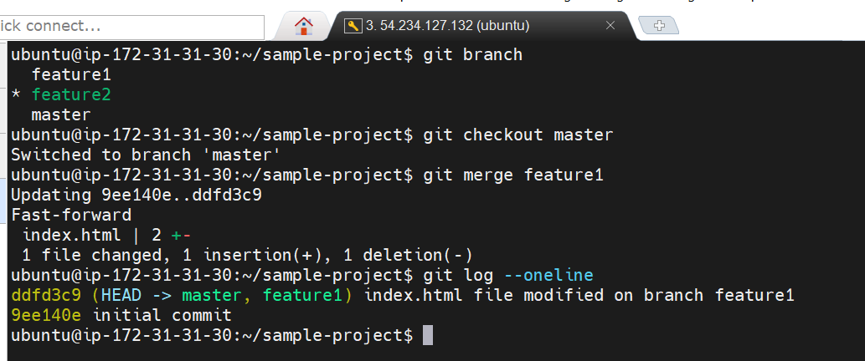

1. **Try and merge branch2(feature2) into the master (merge conflict should arise)**

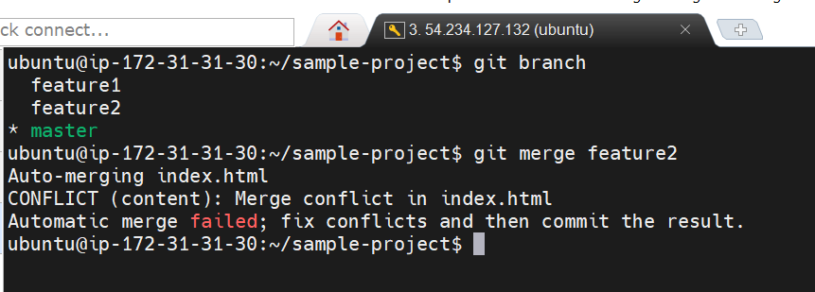

1. **Install a merge tool of your choice and resolve the merge conflict using git** **mergetool command**

**---using vimdiff3 tool**

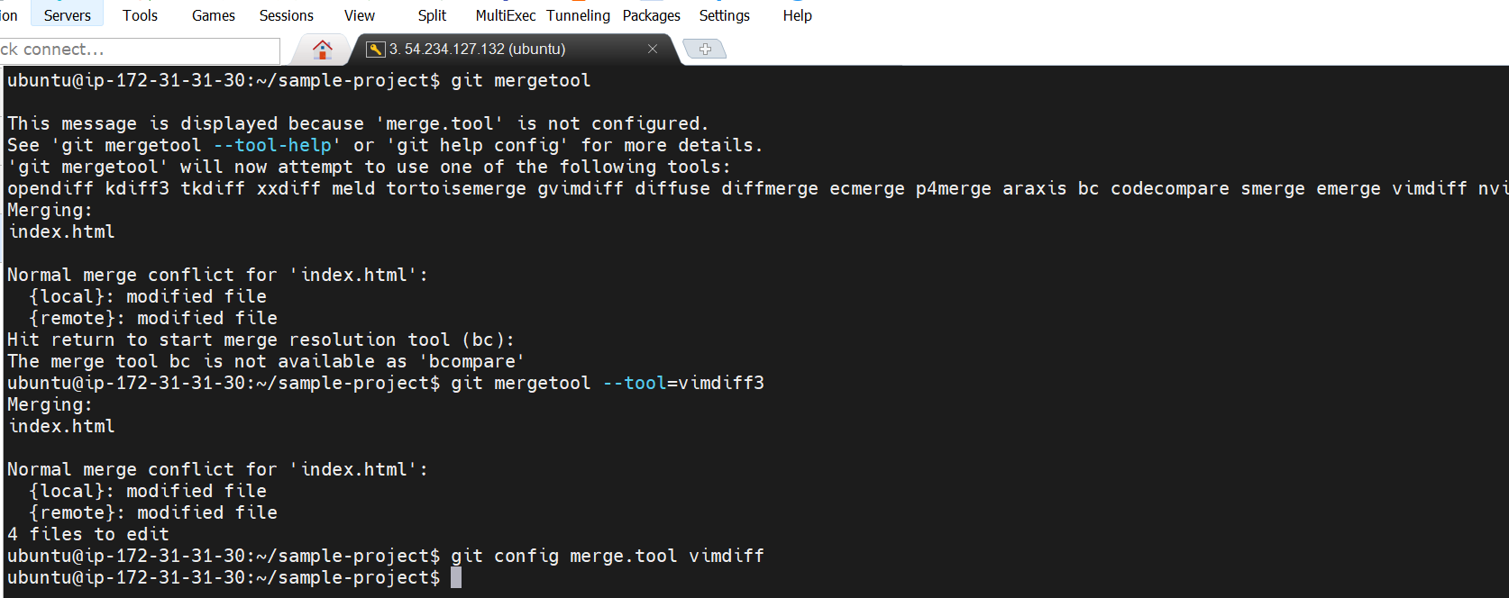

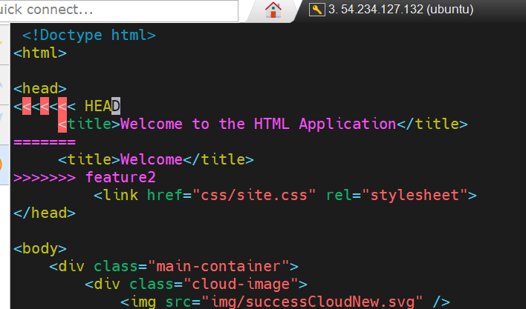

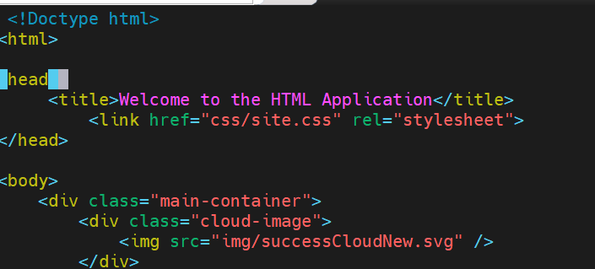

Add the code which are required and remove the unwanted code.

Save the file.

Commit the modified file to resolve the conflicts.

Check all commits using the command:-

git log --oneline

